
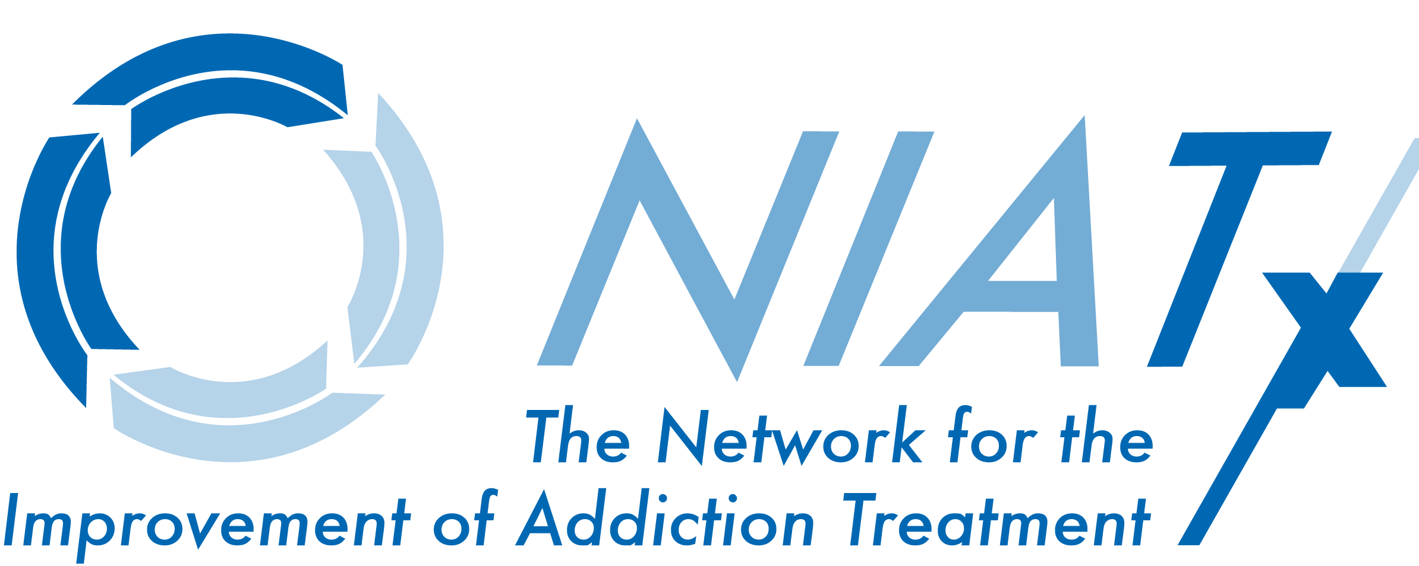

Improving Patient Access and Retention (NIATx)

“More than 60% of our patients leave treatment within the first month…”

“The current wait time for an assessment or admission appointment is 21 days…”

“Our admissions average 18 patients a month, but we have room for 40 patients…”

“Half of our prospective patients do not show up for their assessment appointment…”

Do any of the above scenarios sound familiar to you? If so, you could benefit from learning more about the Network for the Improvement of Addiction Treatment (NIATx) process improvement model. The following information is meant to provide Treatnet Focal Points with an overview of this model, which has been developed to assist substance abuse treatment organizations in making changes to their policies and procedures that can lead to improvements in client access to and retention in treatment.

The bottom line is this: If you are faced with issues such as getting patients into treatment or keeping them engaged long enough to reap the benefits of treatment, this information can help you! The following information can help you to answer these questions:

“What are the problems that NIATx can help me solve?”
“How do I know what to change to solve the problem?”
“How will I know that the change works?”

What Problems Can NIATx Help Solve?
Founded in 2003, the Network for the Improvement of Addiction Treatment (NIATx) works with addiction treatment and behavioral health care organizations to improve access to and retention in treatment for patients seeking help with substance abuse. NIATx is a division of the University of Wisconsin–Madison’s Center for Health Enhancement Systems Studies (CHESS).

NIATx works with its member organizations and the field at large to use process improvement strategies that address four aims:

 Reduce Waiting Times

 Reduce No-Shows
 Increase Admissions

 Increase Continuation Rates

Process improvement is a way to identify, study, and improve an organisation’s existing systems. NIATx can help Treatnet organisations use process improvement to improve the quality, accessibility, and affordability of drug dependence treatment and rehabilitation services.

The Five Key Principles
Five key principles guide the NIATx model. Research conducted in Europe, the United States, and Canada generated a list of 80 factors critical to promoting change in organisations (Gustafson and Hundt, 1995). Tests for statistical significance revealed that only five of these factors consistently influenced efforts to overcome barriers to process improvement:

- Understand and involve the customer
- Fix the key problems
- Pick a powerful change leader
- Get ideas from outside the organisation or field
- Use rapid-cycle testing to establish effective changes

A Model for Improvement: Five Questions
If these five principles are what really matter when making innovative changes in organisations, how can they be integrated into a problem-solving process for improving organisations? The NIATx way focuses on answering five questions:

- What’s it like to be our customer?
- What are we trying to accomplish?
- How will we know a change is an improvement?
- What changes can we test?
- How can we sustain the gain?

Q1: What’s it like to be our customer?
One of the most effective tools to help agencies understand what it is like to be a customer is the walk-through. In a walk-through, staff members take the roles of a new client and a family member and literally walk through the treatment processes just as a client would. The goal is to see the agency from the client’s perspective. Taking this view of treatment services—from the first call for help, to the intake process, and through final discharge—helps NIATx members understand how the customer experiences the process of treatment and their feelings about it.

Q2: What are we trying to accomplish?
Information from the walk-through helps the “Change Team” decide what they hope to accomplish through their “Change Project.” A Change Project is a process improvement activity that targets one aim, one level of care, one location, and one population. NIATx members learn how to conduct a Change Project to get more people into treatment and keep them engaged in treatment for a longer time.

The first step of a Change Project is for the Executive Director of the organization to choose a staff member to serve as the Change Leader. Together, the Executive Director and the Change Leader invite staff members from throughout the organization to join the Change Team. Effective Change Teams often include an actual client or customer.

Q3: How will we know a change is an improvement?
Before beginning a Change Project, a Change Team needs to consider:

- Which changes are the most important?
- How will we know which changes worked and which did not?

To address these questions, the Change Team collects data before, during, and after testing the change. Using the data, the team can measure, evaluate, and compare their progress towards the goal they’ve set. These six steps help guide members in their consideration of whether a change results in an improvement.

- Define your measures. Change Teams establish clear measures and definitions prior to the start of a Change Project. The measures should clarify the project objectives and should be agreed upon by key stakeholders.

- Collect baseline data. The Change Team defines a starting point for the change and works backwards to collect two to three months of baseline data before making any changes.

- Establish a clear aim—for example, reduce client no-shows from 65% to 25%.

- Consistently collect data. An important part of the Change Project is collecting measurement data on a regular and consistent basis using the agreed upon definitions.

- Chart your progress. Over time your agency will collect both pre-change (baseline) and post-change data. Share the data with the Change Team as well as others in your organisation. Charts are effective, but these powerful visual aids should follow one simple axiom: one chart, one message.

- Ask questions. What is the information telling me about change in my organisation?


Q4: What Changes Can We Test? The Plan–Do–Study-–Act (PDSA) Cycle
After using the walk-through to identify areas for change, the Change Team completes a PDSA cycle to turn a change idea into action.

- Plan the change and how to test if it is an improvement or not. Change Team members should ask themselves: “What is the aim of the change, and how can we test whether that aim is being met? What do we predict will happen? What steps are needed to prepare for the test (Who? What? Where? When?)?

- Do the plan. Document problems and unexpected observations. Begin to analyse the data.

- Study the results. Complete the analysis of the data. Compare the actual results to the predicted results. Has the change resulted in an improvement? Why or why not? Summarise what has been learned.

- Act on the new knowledge. Should the change be increased in scope or tested under different conditions? Should the change be adopted, adapted, or abandoned? What will be the next cycle?

Q5: How can we sustain the gain?

Successful Change Teams keep an effective change alive in their organisation by continually monitoring its effectiveness. They also adapt the change to changing conditions, allowing the change to evolve as necessary for gains to continue.
How Do We Know It Works?
Since the programme’s inception in 2003, NIATx members have demonstrated improvements in each of the four project aims. As of March 2006, members reported, on average, the following improvements:

- 34.8% reduction in wait times (31 organisations reporting)
- 33.0% reduction in no-shows (27 organisations reporting)
- 21.5% increase in admissions (22 organisations reporting)
- 22.3% increase in treatment continuation from the first to the fourth session in 30 days (31 organisations reporting)

The NIATx Website: www.niatx.net

NIATx offers its members and the field at large an array of information, resources, and process improvement tools on its Web site. The site is regularly updated with articles on process improvement, change ideas, and best practises from NIATx member organisations. The site also offers information on upcoming events and presentations, related publications, and other online resources to help addiction treatment agencies and behavioural health organisations improve access to and retention in treatment. A how-to guide for using the NIATx Web site is posted in the Volume D section of the Treatnet Web site, located at: http://www.uclaisap.org/InternationalProjects/html/unodc/TrainingVolumes/Volume%20D/training-package-volD.html .

The NIATx staff thanks Treatnet for the opportunity to explain how we help agencies improve access and retention. We invite you to e-mail us at info@niatx.net with any questions.

